9/16/2022

Thaw Dar Shwe, Ngu War (Cognizant)

nguwar.thawdarshwe@cognizant.com

EAuction Project

Front-end Angular Application

Table of Contents

1. Introduction 2

1.1. Purpose 2

2. Front-end Design and Implementation 2

2.1. UI Diagram 2

2.2. UI Implementation 2

2.3. Technologies used 3

# Introduction

## Purpose

This document provides a comprehensive front-end development and UI overview of the EAuction project. It is intended to capture and convey the significant decisions made and technologies used in the system.

# Front-end Design and Implementation

## UI Diagram

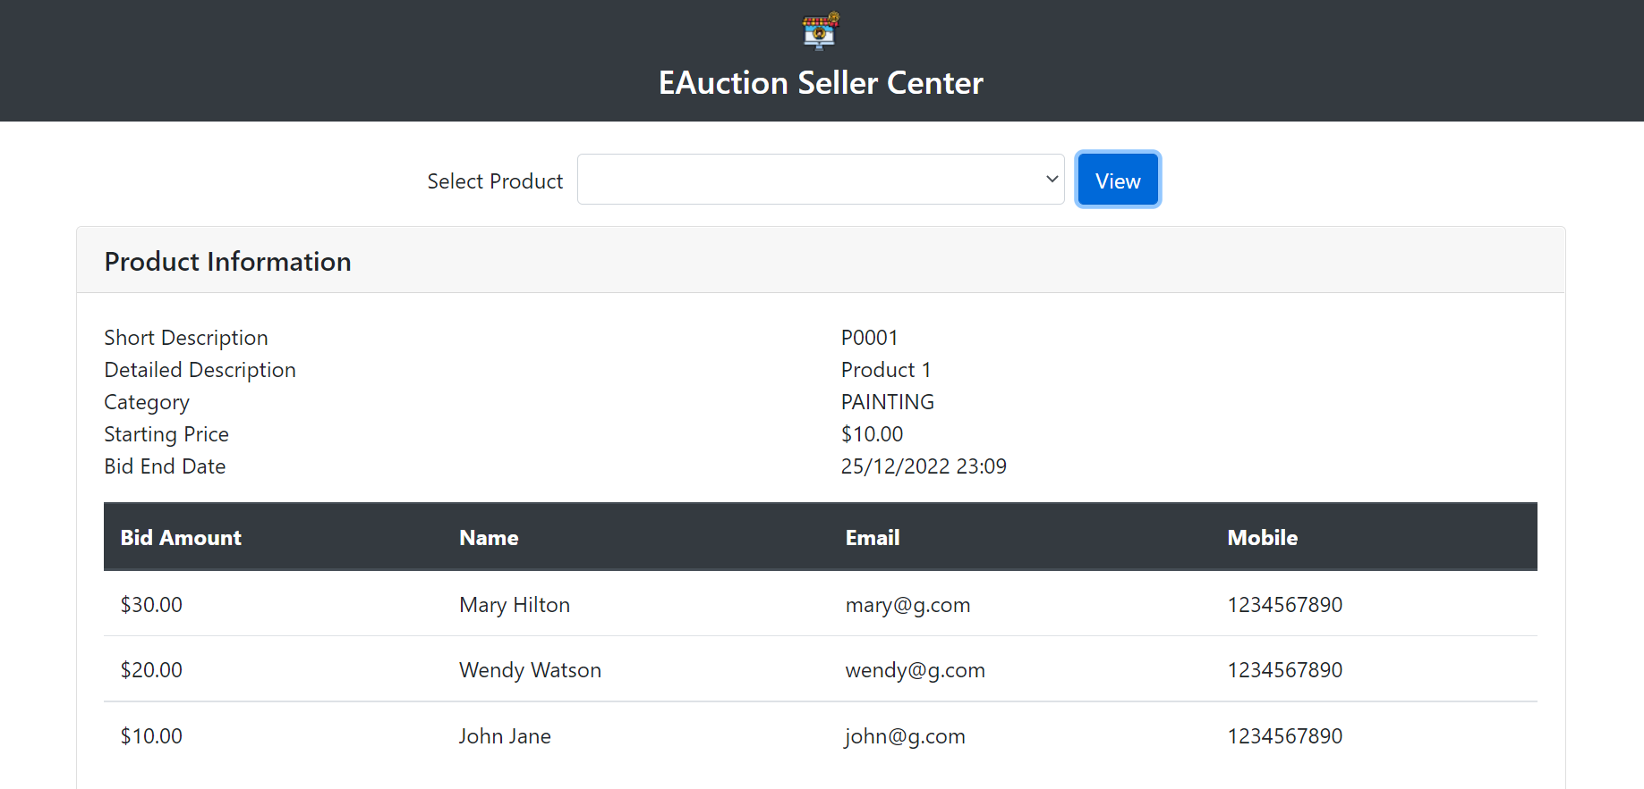

## UI Implementation

EAuction project will be developed by using Angular and Bootstrap framework. Front-end application will call the rest endpoints exposed by API Gateway, which then call spring boot microservices for retrieving product and bid information.

The application will mainly use interpolation for content binding as it is always escaped. In addition, Content Security Policy (CSP) will also be turned on as a further defense-in-depth technique for XSS injection attack.

In order to improve the performance, the application will load JQuery from CDN to faster serve the library. JQuery and Bootstrap minified version will also be used to speed up the website.

## Technologies used

The following are the technologies used in Frontend Angular Application.

* Angular14
* Bootstrap for styling
* Jasmine for unit testing
* Karma for test runner
* Cypress for end-to-end testing
* Code coverage generation and report
* Webpack for packaging the application